**Ancient Greece in Silent Cinema**

**Friday, 17 October, 18.00-19.30**

**Auditorium Theo Angelopoulos, Institut français**

**31 Sina Street, Athens**

**Introduction: Pantelis Michelakis**

**Live original music:** **Minas I. Alexiadis**

**Le tonnerre de Jupiter** / **Jupiter's Thunderbolts** (Georges Méliès, Star Film Company, France, 1903, 4 min)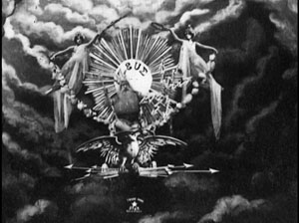. In a positively magical opening […] a cloudy heavens is shown with the sun rising through a clearing, an eagle underneath the sun, and Jupiter king of gods upon the eagle. He dismounts the eagle and strides about the cloudy heavens baring thunderbolts, and performs a fancy-dance with Mercury. They then appear in a hall of a celestial palace on Mount Olympus. Vulcan comes by with some newly-forged thunderbolts, which Jupiter accidentally sets off prematurely knocking himself over, so he gets rather peevish with Vulcan and Hermes, chasing them away. He then tosses bolts around the hall for the hell of it. The Muses appear to him, and he dances the fandango with one of them. In the conclusion Jupiter stands alone center stage setting off thunderbolts willy-nilly. Summary from http://www.weirdwildrealm.com/f-melies7.html

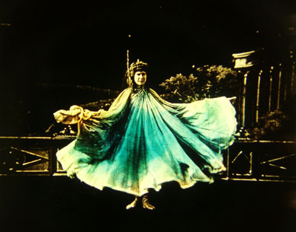**‘Serpentine dance’ by imitator of Loie Fuller** (Pathé Frères, France, 1905, stencil colouring, 1 min). A bat hovers over a Hellenic decor. It stops and becomes Loie Fuller. She is clothed in a long silk tunic. Grabbing her tunic with both hands, she displays rotating and helicoid movements. While swirling, her dress changes colours regularly. At the end of the number, completely wrapped in her robe, she gradually disappears. Summary from the database of the Centre national du cinéma et de l’image animée (CNC)

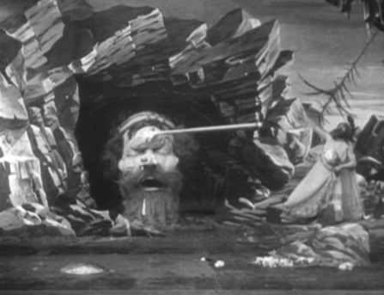

**L’Île de Calypso ou Ulysse et le géant Polyphème / The Island of Calypso or Ulysses and the Giant Polyphemus / The Mysterious Island** (George Méliès, France, 1905, 4 min). A shipwrecked Ulysses arrives at the island of Calypso. She seduces him with the help of her dancing companions. Ulysses meets the giant Polyphemus and blinds him with a spear. He then departs leaving Calypso broken-hearted.

**Amour d’esclave / A Slave’s Love** (Albert Capellani, Pathé Frères, France, 1907, stencil colouring, 11 min). Ancient Athens. Polymos falls in love with the slave Chloë. Polymos is bored by the attention of merchants and their rich goods. He dismisses them angrily. His wife, Chrysis, sends for the slave girl Chloë to dance for Polymos. Polymos is much taken with the dance and the dancer and goes to embrace her only to be separated by his wife who dismisses Chloë. However, once Chrysis has gone, Polymos follows Chloë into the garden. There he observes her giving flowers in offering to the God of nature, Pan. She kisses the statue. Polymos makes his presence known and they embrace in a long kiss. They part blowing kisses to one another. Polymos retires to his bed. Chloë enters his quarters and places some perfume on a dying fire which then bursts into flame. Polymos dreams of Chloë dancing with a corp de ballets and veils. Polymos awakens and embraces Chloë. However, Chrysis enters the room and orders Chloë to be taken to the dungeons. Once there, Chloë is offered poison or death by whipping on a post. She chooses the poison and drinks it. Polymos enters the cell and stops the guard from whipping Chloë. She dances for Polymos once more but dies in his arms. He realises she has taken poison and drinks it himself to be united in death with her. His wife enters and is stricken by his death.’ Summary from the *Films Pathé frères, supplément*, May 1907, p. 202-203, as taken from the database of the American Film Institute. Incomplete: main title, credits and part of picture lacking; film ends abruptly. Intertitles: Temptation; The kiss of love; A dream, awful reality; Poison, united in death.

**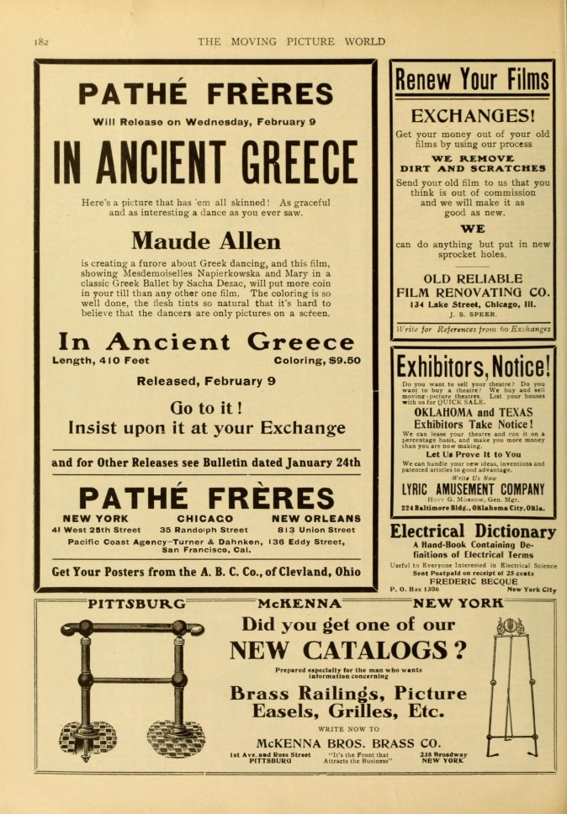Dans l’Hellade / In Ancient Greece** (Pathé Frères, France, 1909, stencil colouring, 4 min). Starring Stacia Napierkowska and Maude Allen. Based on an interpretation of the ballet by Sacha Dezac. “This is an entirely charming and most artistic production, beautifully conceived and perfectly interpreted. It is a little ballet, having for subject a Greek idyll between boy and girl.” (*The Bioscope* 19 August 1909). “A sort of ‘Salome’ dance. Two principals are used. A girl performs the dance and a youth figures incidentally. The pair wear the scant garments of the ancients, not so scant, either, after seeing the real article in vaudeville. The producers are to be thanked for putting a sufficient amount of clothing upon the pair instead of trying to trade upon indecency. The picture and the dance was probably meant to be ‘classical’ but there are few classic minds in a picture house audience, so the reel just occupies time.” (*Variety* 19 February 1910)

**\\ads.bris.ac.uk\filestore\Arts2\hums\clxpm\research\book Tragedy on Screen\waste\illustrations\PDVD_004.TIFFElettra / Electra** (Aquila Films, Italy, 1909, 9 min). Agamemnon lies dying, murdered by his wife Clytemnestra. Before he is sent away from the palace, Orestes is begged by his sister Elektra to avenge their father one day. She waits ten years for him. On his return, she takes him to where Clytemnestra is sleeping. As he deliberates, armed guards force their way in. Orestes defeats them in swordplay, then kills his mother. Next he kills her lover. Elektra and Orestes display the two dead bodies to the crowd outside the palace. Intertitles: Orestes is removed from the royal palace and is sent to his uncle in Phocis; Electra asks her brother Orestes to swear on his return to avenge their father; Electra awaits the revenge; Orestes’ return ten years later; The Revenge.

**Dances of the Ages** (J. Searle Dawley, Thomas A. Edison Inc., USA, 1913, 5 min). Norma Gould, Ted Shawn and dancers perform miniaturized on a banquet table top brief **dances** evoking historical eras from **the** Stone Age to **the** earlwy twentieth century. “With the two principals in a ballet of forty dancers that is a feast to the eye. Back of this novelty there is woven a simple tale of an old fashioned dancing master, in his little garret room, who still clings to the old fashioned dances of grace and movement. Over his bowl of milk and crackers his head sinks to the table and in dreamland he becomes the dancing master of renown once again. At a great banquet table he meets his old cronies who have come together to discuss the progress of their art and thus, before these gray-haired men, we are shown the Dances of the Ages. On the table before them appear dainty, tiny figures who flit before their gaze; a corps of wonderful miniature dancers.” (*Moving Picture World*, 24 May 1913)

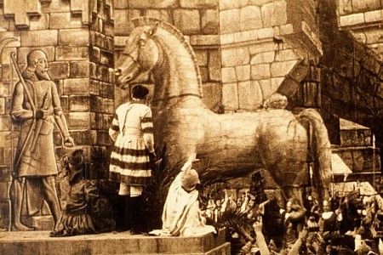**La caduta di Troia / The Fall of Troy** (Giovanni Pastrone & Romano Luigi Borgnetto, Itala Film, Italy, 1910, 29 min). Homer sings to the Greeks of the exploits of the heroes of the Trojan war. Menelaus, King of Sparta, takes leave of his wife Helen. Paris arrives as Ambassador from Troy and is received by Helen. He is greatly struck by her beauty. The goddess Venus comes to his aid and the couple are wafted in a gigantic seashell to Troy. The news reaches her husband, and to avenge the insult, the Greeks declare war on Troy. They lay siege to the city but are repulsed. The Greeks feign return, leaving behind a wooden horse which the Trojans decide to move into the city. A spy carries the news to the Greeks. That night, the Greek warriors hidden in the horse emerge and fire the city. Fierce fighting ensues. Paris and Helen seek to escape but Menelaus and his men find them. Paris is killed by Menelaus in single combat, and Helen is captured, to be removed in bonds to Sparta.

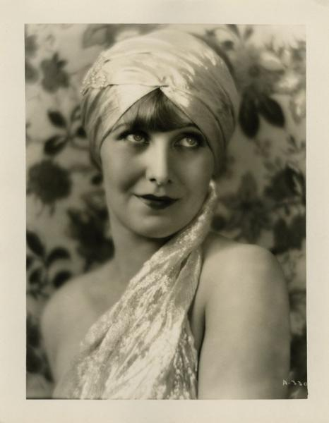**The Private Life of Helen of Troy** (Alexander Korda, First National Pictures, USA, 1927, final section of now largely-lost film, 6 min). Elaborate burlesque of the Trojan myth. “Queen Helen of Troy, piqued by her husband’s lack of interest in her, elopes with Paris to Sparta. Menelaus, her husband, egged on by his henchman, starts a war with Paris, finally effecting the return of Helen. The time-honoured custom demands that he have the pleasure of killing her, but her seductive loveliness restrains him. And so at the end of the story, we find Helen engaging in a new flirtation with the Prince of Ithaca” (*Moving Picture World*, 17 December 1927). Only two fragments of the film survive.

**Acknowledgments**

We are extremely grateful to the French Institute at Athens for hosting this screening; to the French School at Athens, the British School at Athens and the Institute of Greece, Rome and the Classical Tradition, University of Bristol for supporting the screening; to Nicoletta Moimigliano for the suggestion to hold it in tandem with the Hellenomania Colloquium and for valuable advice; and to our pianist Minas I. Alexiadis for his enthusiastic participation. We are also very indebted to the National Archive of the British Film Institute, the Library of Congress, the New York Library for the Performing Arts, the EYE Film Institute of the Netherlands, and the Cineteca di Bologna for the loan of these films from their collections, and to Jo Botting, Kathleen Dickson, Bryony Dixon, Mariann Lewinsky Sträuli, Elif Rongen, Ronny Temme for their research in the archives on our behalf.

This screening is part of an international collaborative project on the ancient worlds of silent cinema coordinated by Pantelis Michelakis (University of Bristol) and Maria Wyke (University College London). For more information on the topic see *The Ancient World in Silent Cinema,* edited by Pantelis Michelakis and Maria Wyke, Cambridge University Press, 2013, www.cambridge.org/9781107016101

Pantelis Michelakis

University of Bristol

P.Michelakis@bris.ac.uk