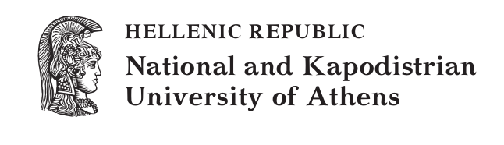
Shakespeare in Greece / Greece in Shakespeare

Tuesday 25 October 2016

“Kostis Palamas” building

Organized by Vassiliki Markidou, Efterpi Mitsi
(Department of English Language and Literature)
and Xenia Georgopoulou (Department of Theatre Studies)

PROGRAMME

9:15-9:30 Welcome -
Evangelia Sakelliou-Schultz, Chair of the Department of English Language and Literature, National and Kapodistrian University of Athens

9:30-10:15 1st Plenary Lecture:
Alison Findlay, Lancaster University
“Re-Shaping Athens in A Midsummer Night’s Dream and The Two Noble Kinsmen”
(Chair: Vassiliki Markidou)

10:15-10:45 Coffee break

10:45-12:15 1st session: Greece and the Greeks in Shakespeare
(Chair: Mina Karavanta)
Efterpi Mitsi, National and Kapodistrian University of Athens
“Greek Heroes and ‘strutting players’ in Troilus and Cressida”
Vassiliki Markidou, National and Kapodistrian University of Athens
“‘To take our imagination / From bourn to bourn, region to region’: The Politics of Greek Topographies in Pericles”
Nic Panagopoulos, National and Kapodistrian University of Athens
“Plato’s Republic and King Lear: The Theme of Justice”

12:15-13:00 2nd Plenary Lecture:
John Drakakis, University of Stirling
“Hospitality, Friendship and Republicanism in Timon of Athens”
(Chair: Aspasia Velissariou)

13:00-14:00 Lunch break

14:00-15:30 2nd session: Shakespearean Afterlives
(Chair: Nic Panagopoulos)
Aspasia Velissariou, National and Kapodistrian University of Athens
“‘And makes it indistinct / As water is in water’: The Melting Away of the Heroic Subject in Shakespeare’s Antony and Cleopatra and Dryden’s All for Love”
Xenia Georgopoulou, National and Kapodistrian University of Athens
“Shakespeare in the popular culture of 21st century Greece”
Mina Karavanta, National and Kapodistrian University of Athens
“Blood Fictions: The Nature of Race Thought in Caryl Phillips’ Othello”

15:30-16:15 3rd Plenary Lecture:
Rob Maslen, University of Glasgow
“Generals and Degenerates in Shakespeare’s Trojan History”
(Chair: Efterpi Mitsi)

16:15-16:45 Coffee break

16:45-18:15 3rd session: Shakespeare in Translation
(Chair: Xenia Georgopoulou)
Paschalis Nicolaou, Ionian University
“Re-arrivals at Troy: Greek Responses to Troilus and Cressida’s Textual Complexities”
Vasso Yannakopoulou, University of Cyprus
“The Fickle Nature of a Danish Prince in Greek”
Nikos Ηatzopoulos, translator, director and actor
Xenia Georgopoulou, National and Kapodistrian University of Athens
“Errikos Belies on Shakespearean Translation”

18:15-19.45 Round table: Shakespeare on the Greek Stage
(Chair: Xenia Georgopoulou)
Georgina Kakoudaki, director and theatre teacher
Savvas Stroumpos, director and actor
Alexandros Sotiriou, director and actor

Funded by the Department of English Language and Literature & by the Special Account for Research Grants of the National and Kapodistrian University of Athens

Special thanks go to the Department of Theatre Studies, National and Kapodistrian University of Athens

We would also like to thank our postgraduate student Nikitas Paterakis for the poster design.

