

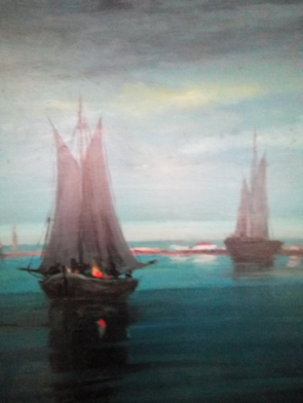

4th INTERNATIONAL WORKSHOP

**Travels and Travelers**

Syros, Greece July 1–3, 2019

The International [Commission on Science and Literature](http://coscilit.eap.gr/" \t "_blank) DHST/IUHPST, The School of Humanities of the Hellenic Open University and the Institute of Historical Research/National Hellenic Research Foundation organize a three-days’ workshop to study “Travels and Travelers” in a multidisciplinary perspective within Science, Philosophy and Literature. **.** The CoSciLit workshop is already an established part of the very prestigious “Hermoupolis Seminars” which have been organized for more than 30 years every July on Syros Island.

This workshop aims to discuss various views for the role and presence of travels and travelers in science, philosophy and literature. The conference offers an open forum for all scholars interested in this growing research field, thus bringing into the dialogue multiple perspectives and different disciplines in order to build communication and cooperation bridges between science, philosophy, and literature.

**Call for Papers:**

We invite paper proposals including a title, an abstract of 300 words (max.), name, and affiliation of the author, as well as contact information. The presentation time is 20 minutes with additional 10 minutes for discussion. The conference language is English.

Please submit your proposal via email [gvlahakis@yahoo.com](mailto:gvlahakis@yahoo.com) or via <http://st-slsaeu2019.indigoflicks.com> by February 28, 2019. Response of acceptance will be given at the latest by March31, 2019.

**Location:**

The venue of the workshop will be the “Historical Archives of the State” in the Town Hall of Hermoupolis. Hermoupolis was once the capital of Greece and a city of great cultural, scientific, and industrial heritage. Syros Island is very close to Piraeus by boat and an ideal place for a high quality, inexpensive summer visit.

Participants are asked to make their own arrangements concerning their arrival and accommodation, but the conference organizers will be happy to give any necessary assistance.

Coffee and refreshments will be offered.

For further information please visit <http://st-slsaeu2019.indigoflicks.com>

**Organization:**

George N. Vlahakis, Commission on Science and Literature DHST/IUHPST and Hellenic Open University, Greece

Efthymios Nicolaidis, Institute for Historical Research / National Hellenic Research Foundation, Greece

Konstantinos Tampakis, Institute for Historical Research / National Hellenic Research Foundation, Greece

